PROJECT DOCUMENTATION

**STAGE PLAN**

|  |  |
| --- | --- |
| **Project:** | **Business Management System for Lanka Tools (Pvt) Ltd** |
| Release: | August 2022 |
| Date: | 29th July 2022 |
|  |  |
| **PRINCE2** |  |
|  |  |
| Author: | Bhathiya Kannangara, Ruwanthi Narampanawa |
| Owner: | Dr Yasas Jayaweera (Project Executive) |
| Client: | Lanka Tools by H.F.Athaf |
| Document Ref: | StagePlan02_SmartBMS |
| Version No: | 1.1 |

# 1 Stage Plan History

## 1.1 Document Location

This document is only valid on the day it was printed.

The source of the document will be found on the project's PC in location

## 1.2 Revision History

**Date of this revision:** 07/21/2022

**Date of Next revision:**

|  |  |  |  |
| --- | --- | --- | --- |
| **Revision date** | **Previous revision date** | **Summary of Changes** | **Changes marked** |
| 07/29/2022 |  | First issue |  |
|  |  |  |  |

## 1.3 Approvals

This document requires the following approvals.

Signed approval forms are filed in the Management section of the project files.

|  |  |  |  |  |
| --- | --- | --- | --- | --- |
| **Name** | **Signature** | **Title** | **Date of Issue** | **Version** |
| Dr.Yasas Jayaweera |  | Project Board | 07/29/2022 | 1.0 |
| Bhathiya Kannangara |  | Project Manager | 07/29/2022 | 1.0 |
| Mr. H.F.Athaf |  | Client | 07/29/2022 | 1.0 |

## 1.4 Distribution

This document has been distributed to:

|  |  |  |  |
| --- | --- | --- | --- |
| **Name** | **Title** | **Date of Issue** | **Version** |
| Bhathiya Kannangara | Project Manager | 07/29/2022 | 1.0 |
| Imanka Jayasiriwardena | Startup Manager | 07/29/2022 | 1.0 |
| Layan Perera | Quality Manager | 07/29/2022 | 1.0 |
| R.A.G.U.T.Rajapaksha | Risk Manager | 07/29/2022 | 1.0 |
| Ruwanthi Narampanawa | Scheduling Manager | 07/29/2022 | 1.0 |

# 2 Table of Contents

Page

1 Stage Plan History 2

1.1 Document Location 2

1.2 Revision History 2

1.3 Approvals 2

1.4 Distribution 2

2 Table of Contents 3

Stage Plan 4

3 Purpose 4

4 Plan Description 5

5 Quality Plan 5

6 Plan Prerequisites 5

7 External Dependencies 6

8 Tolerances 6

9 Monitoring and Control 6

10 Reporting 6

11 Planning Assumptions 7

12 Graphical Plan 7

12.1 Gantt or Bar Chart 7

12.2 Product Breakdown Structure 8

12.3 Product Flow Diagram 9

12.4 Activity Network 9

12.5 Financial Budget 10

12.6 Resource Requirement Table 11

12.7 Risk Assessment 11

12 Product Descriptions 11

# Stage Plan

## 3 Purpose

This document will reflect how the objective planned for this stage is achieved and will give clear visibility on the sprint 02 objectives, target timelines and resource allocation and how and when the planned objectives will be achieved.

## Plan Description

The project plan aims to identify the valuable aspects, activities, and resources for the project. Additionally, it is necessary to describe how and when the project's goals will be attained. It offers an assessment of project costs and management stages, as well as other crucial control issues, for the business case. It gives the Project Board a place to begin tracking project improvement.

This sprint starts on 07/29/2022 and ends on 08/12/2022. Complete system should available including front end and the backend. The following tasks need to be completed within this sprint:

* User interface development for each module (Employee, Attendance and Payroll)
* Back end development for each module (Employee, Attendance and Payroll)
* Unit Testing
* Integration testing



Task allocation to each resources done in Jira based on the team’s technical roles. Three resources (developers) has been allocated to achieve the target timelines. The person in charge of the tasks should inform the project manager of its progress at the end of each day. The project manager has a thorough understanding of how the project is moving based on the daily updates. As a result, the project manager can quickly intervene if necessary. Scheduling manager checks whether the project is happening according to time and manage it. The Gantt chart will be used as a benchmark for measuring the Sprint's development. The quality manager will use a predetermined set of test cases to test the finished product at the end of the sprint in order to assess the project's quality and completion.

## Quality Plan

“Quality Plan version 1.0” document is uploaded to the project's GitHub repository for documents (https://github.com/justpbk/SPPM) and it should be located in the Week 4 folder.

## Plan Prerequisites

The strategy implies that every requirement has been gathered and decided upon. The budget has also been agreed upon with the client. To understand how other systems in this space operate, similar systems must be examined.

## External Dependencies

Performance of the web application and DB is totally relay on the hosting provider and the strength of the internet connectivity. This requires uninterrupted network connectivity for the smooth business operation. Frequent password change required in SMPP/SMTP connection to ensure the security of the accounts.

## Tolerances

Tolerances are the limitations on how much you may change your project without having to resubmit it for approval. We might slightly exceed or fall short of the tolerance and won't need to continually going back to our project sponsor to get any adjustments approved. The project sponsor, on the other hand, is in responsible of decisions that have an influence on the project budget and schedule, and changing these will deviate from the predetermined course of action. A budget of Rs. 227,800 with a 10% tolerance has been granted by Mr. H.F.Athaf, meaning we can spend up to Rs. 250,580 before requesting more clearance. A time tolerance is when we can be behind or ahead of the schedule according to the project schedule dates. The clients were kind enough to grant an additional month for the full implementation due to the developers' responsibilities to their undergraduate project, jobs, and personal lives. However, the project could not in any way be of low quality.

## Monitoring and Control

The goal of controlling a stage process is to divide up the team's responsibilities for keeping track of it, which includes updating the project board on the stage's state and taking the necessary steps to ensure that the stage stays within tolerance.

The team meets daily until this sprint ends using Zoom to review the project's progress and plan the tasks for the next week and whenever the team mates requested a meeting for any clarifications or teams decision required. The work will then be assigned by the project manager using Jira in accordance with the schedule manager's plans. Additionally, the WhatsApp group is used to track the completion of the assigned duties. And also, all completed work packages are returned to the controlling stage, where they are received and evaluated again. The schedule manager can make sure that the project is proceeding in accordance with the planned timetable at this point.

## Reporting

If the allocated time is insufficient, all managers will let the scheduling manager know. The scheduling manager will adjust the schedule at their request in accordance with the project sprint's flow and let the project manager know about the changes.

On the other hand, if any project-related issues come up, the entire team will notify the project manager, who will then provide the necessary instructions. The project board, the client, and any concerns will be informed of the status of the project.

## Planning Assumptions

“Project Plan version 1.0” document is uploaded to the project's GitHub repository for documents (https://github.com/justpbk/SPPM) and it should be located in the Week 4 folder.

## 12 Graphical Plan

### 12.1 Gantt or Bar Chart

“Project Plan version 1.0” document is uploaded to the project's GitHub repository for documents (https://github.com/justpbk/SPPM) and it should be located in the Week 4 folder.

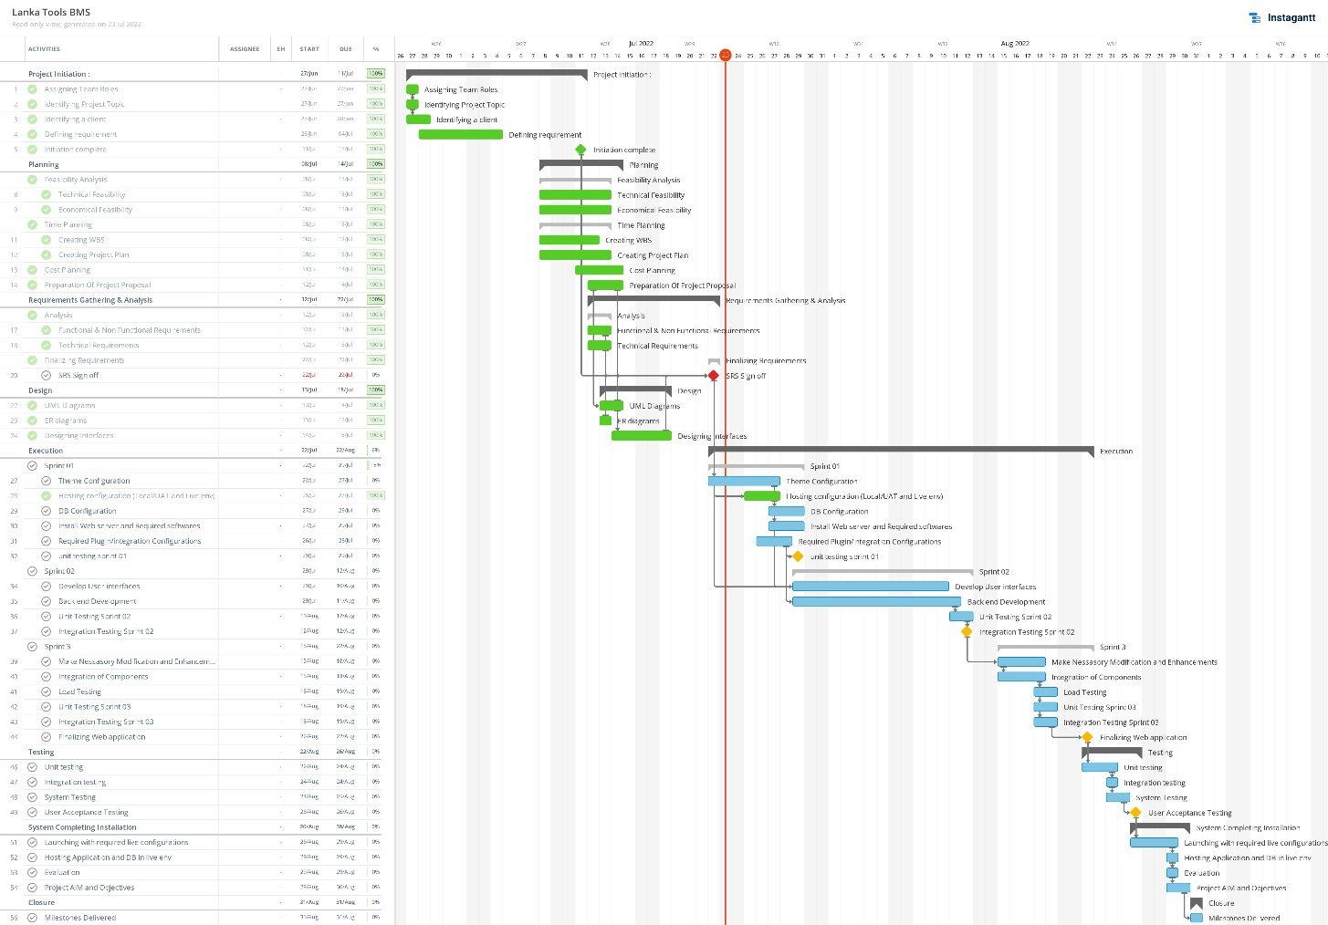

### 

### 12.2 Product Breakdown Structure

### 12.3 Product Flow Diagram

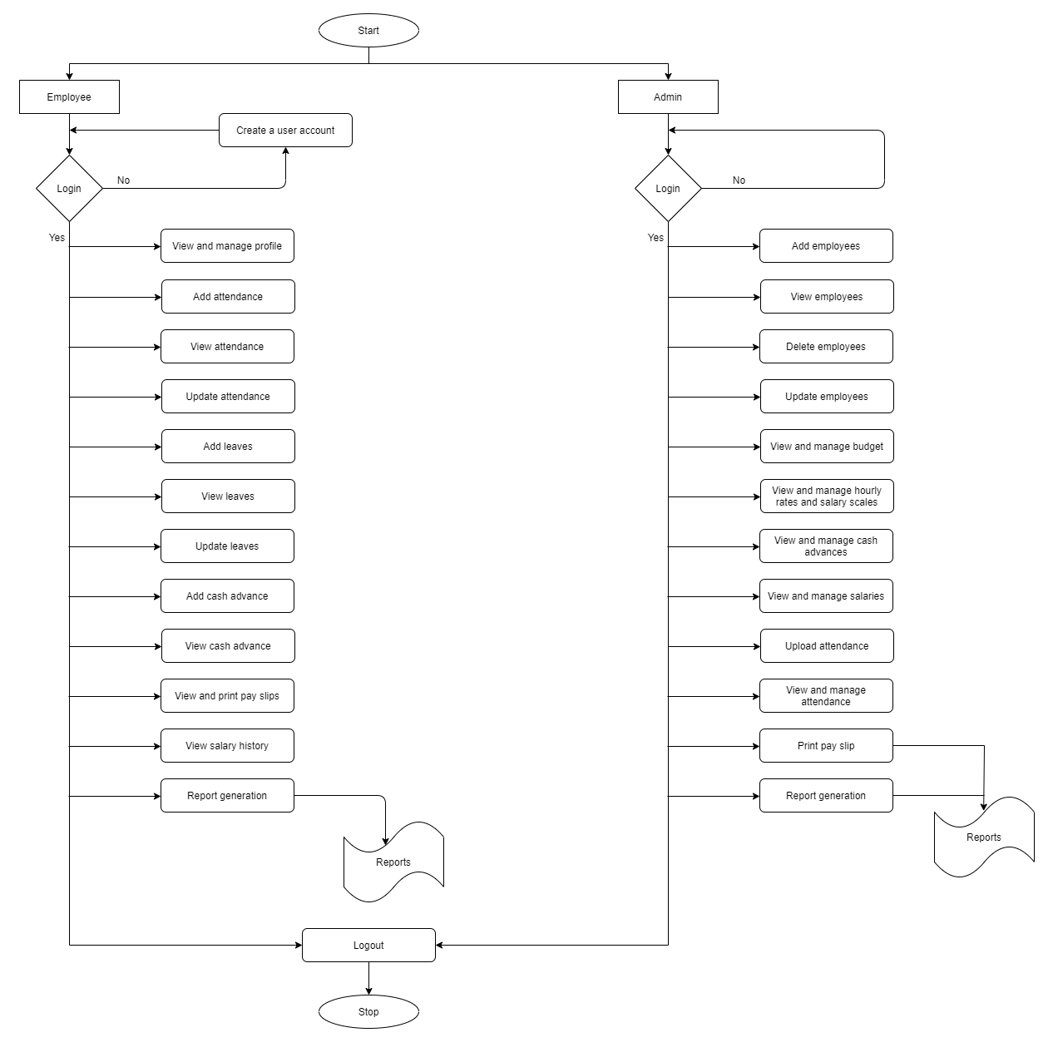

### 12.4 Activity Network

|  |  |  |
| --- | --- | --- |
| Activity | Predecessor | Duration |
| A |  | 6 |
| B |  | 3 |
| C | B | 3 |
| D | B,C | 3 |
| E | D | 3 |
| F | B,C,D,E | 1 |

|  |
| --- |
| A |
| 6 |

|  |
| --- |
| B |
| 3 |

End

Start

|  |
| --- |
| F |
| 1 |

|  |
| --- |
| E |
| 3 |

|  |
| --- |
| D |
| 3 |

|  |
| --- |
| C |
| 3 |

### 12.5 Financial Budget

“Project Plan version 1.0” document is uploaded to the project's GitHub repository for documents (https://github.com/justpbk/SPPM) and it should be located in the Week 3 folder.

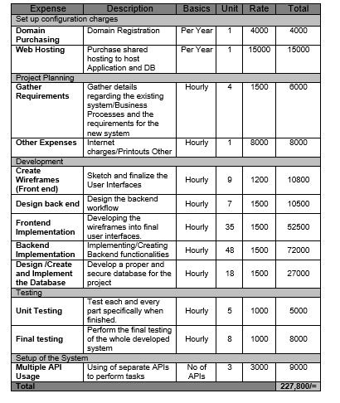

### 12.6 Resource Requirement Table

|  |  |  |  |
| --- | --- | --- | --- |
| ID | Types of resources | Resource details | Quantity |
| 1 | Machine | PC | 5 |
| 2 | Person | Team members | 5 |
| 3 | Person | Board members | 1 |
| 4 | Software | VS Code | 1 |
| 5 | Software | My SQL | 1 |
| 6 | Software | Jira | 1 |
| 7 | Service | Zoom | 1 |
| 8 | Service | Google docs/sheets | 1 |
| 10 | Service | Network Connection | 5 |

### 12.7 Risk Assessment

“Project Plan version 1.0” document is uploaded to the project's GitHub repository for documents (https://github.com/justpbk/SPPM) and it should be located in the Week 4 folder.

## Product Descriptions

“Product description version 1.0” document is uploaded to the project's GitHub repository for documents (https://github.com/justpbk/SPPM) and it should be located in the Week 4 folder.